**ASSIGNMENT NO-03**

* QUERY TO CREATE DATABASE AND TABLES.

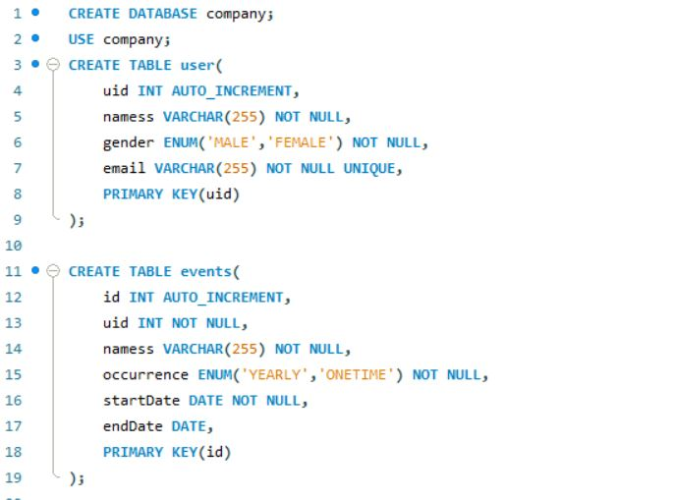

* INSERTING RECORDS IN TABLES

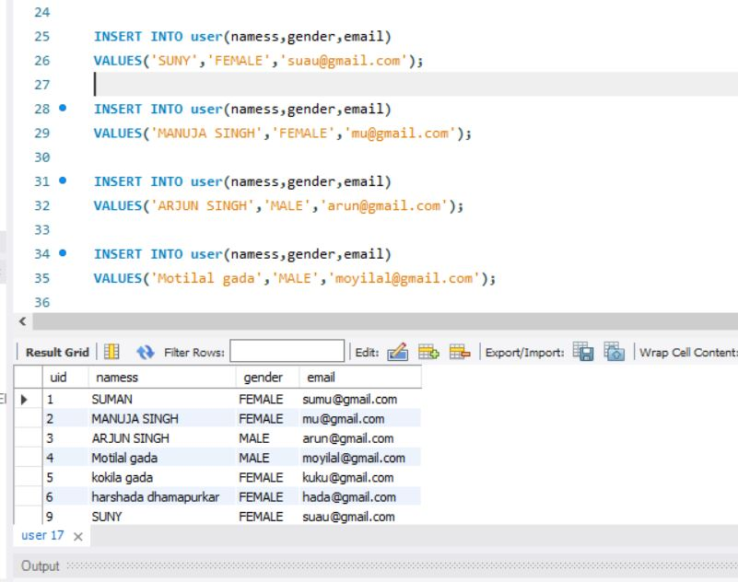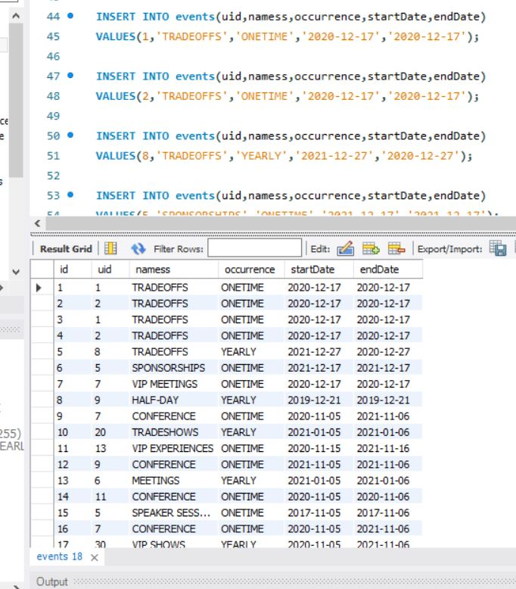

* Query to get all events for today:-

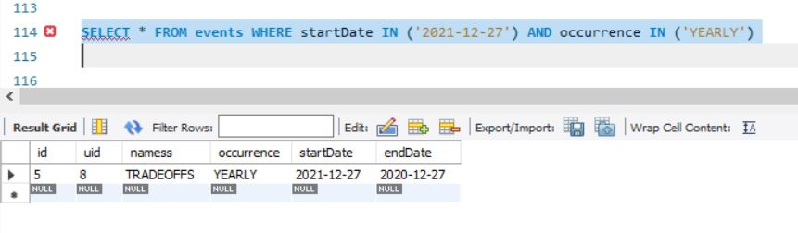

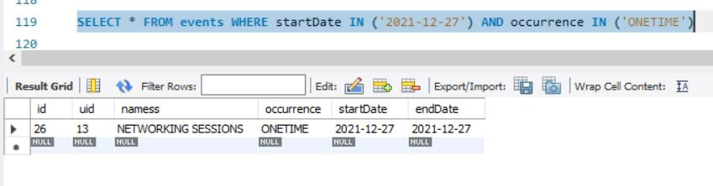

* List to get all the users of List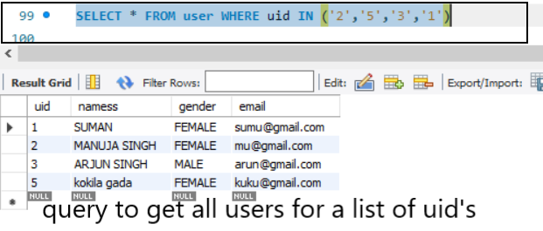:-
* Query to get all the events for a uid:-

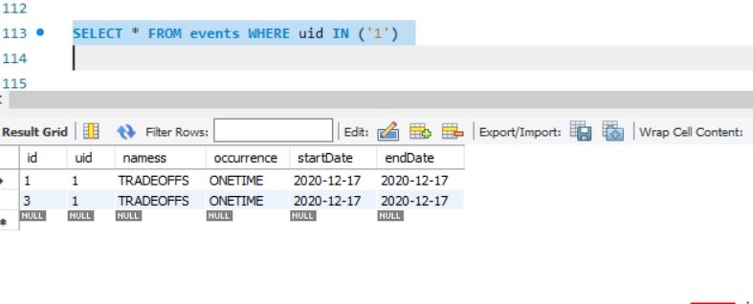

* Query to get all events for next seven days:-

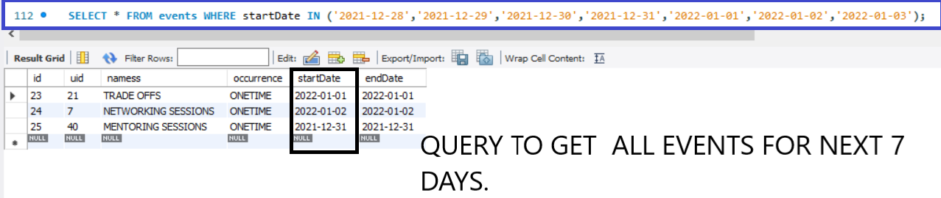

* **Events table:-**

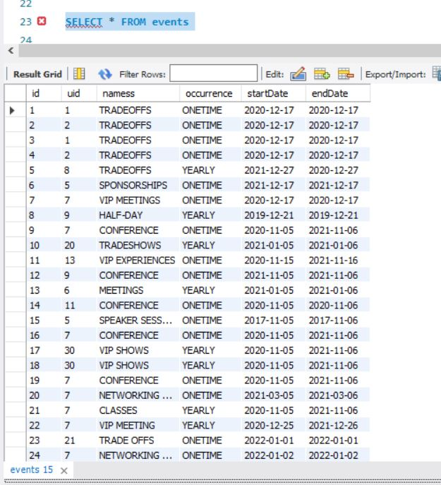

* **Users table:--**

